**Analyzing and Interpreting Natural Selection Data**

On the island of Daphne Major, there is a population of medium ground finch, *Geospiza fortis*. Individuals in this population complete for food, different types of seeds, and the availability of that food is dramatically influenced by year-to-year weather changes.

In 1977 there was a severe drought. The vegetation withered and seeds of all kinds were scarce. The small, soft seeds were quickly exhausted by the birds, leaving mainly large, tough seeds that the finches normally ignore. Birds with larger beaks were able to open these seeds. Smaller finches with less-powerful beaks were not

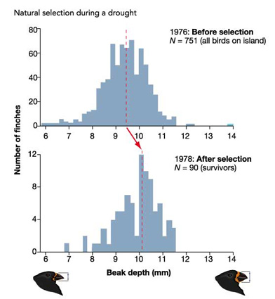

1. Interpret the graphs opposite. How did the **average** beak size change between 1976 and 1978
2. Using your knowledge of microevolutionary forces and the data provided, explain how the finches beak depth changed after the drought in 1977

Today, the rock pocket mouse, *Chaetodipus intermedius*, lives exclusively in rocky habitat across the southwestern deserts of America.

Historically the habitat of the rock pocket mouse was dominated by light-coloured sands. In some areas, however, their habitat has changed over time due to volcanic larva flows, that when cooled led to dark-coloured volcanic rock covering parts of their sandy habitat

The data in the table below shows the coat colour of two populations of Rock Pocket Mice caught at two different locations, A and B over four generations (100 years). Between the second and third generation the mice at location B experienced volcanic larva flows that altered their environment.

Generation

1. Describe the data observed in the table above at both locations. Your description MUST include the following:
   1. A description of how the population changed over time
2. Using your knowledge of the principals of natural selections, explain your observations in the previous question for location B